**Table of content**

1. Introduction to Web Development ------------------- -----------------3
2. Markup Languages--------------------------------------------------------21
3. Cascade Styling Sheet -------- --------------------------------------------27
4. Java Script-------------------------------------------------------------------36
5. My Sql------------------------------------------------------------------------42
6. Php----------------------------------------------------------------------------52
7. ADOBE PHOTOSHOP CS3
8. XAMP
9. WORDPRESS
10. Web Hosting ----------------------------------------------------------------
11. Realisation Of Work / Implementation of live sites

**1. Introduction to Web Development**

**1.1 Clients & Servers**

**Clients (Browser)** :- A client is a piece of computer hardware or software that accesses a service made available by a server. The server is often (but not always) on another computer system, in which case the clientaccesses the service by way of a network.

Examples:-

* Internet Explorer
* Firefox
* Mozilla
* Netscape
* Opera
* Amaya
* AOL
* MSN

**Servers :-** A web server is a computer system that processes requests via HTTP, the basic network protocol used to distribute information on the World Wide Web.

Examples:-

* Apache
* Microsoft
* Netscape
* zeus
* AOLserver
* AV
* JavaWebServer
* Oracle

**1.2 Internet Service Providers:-** Connect Clients to the Internet

Examples:-

* Phone Company
* AOL
* Earthlink
* Verizone
* NetZero
  1. **Domain’s URL’s and IPs**
* Domain name: The specific address of a computer on the Internet eg microsoft.com
* Uniform Resource Locator (URL) eg http://www.microsoft.com/faqs.html
* Internet protocol (IP) address eg 192.168.1.1

**1.4 Creating a Web Site**

* Choose a domain name
* Register with a Registrar
* Choose a hosting service
* Tell Registrar the IP address
* Create web content
* Store (publish) onto hosting server (FTP)
* Submit new site to search engines
  1. **Principles of good web design**
* Visitor-centric, clear purpose
* Progressive disclosure
* Displays quickly
* Browser compatible
* Intuitive navigation
* Spelling, grammar, writing
* Secure (eCommerce)
* Attractive design, easy to read
* Cultural bias? (Regional? Domestic? International?)
* No technical problems (broken links, buggy scripts)
* Maintainable (separate content from style)
* Search Engine Accessible

**2. Markup Languages - HTML**

**2.1 HTML Fundamentals**

* Clear text, case insensitive
* Ignores white space
* Comprised of tags <tag />
* Open tags and closed tags
* Open tags
* <name attributes/>
* <hr/>, <br/>
* <img src=“url” width=‘100px’ height=’60px’/>
* Closed tags
* <name attributes> stuff </name>
* <b>text to be bolded</b>
* <h1>level 1 heading text</h1>
* Comments
* < ! - - comment text -- >

**2.2 Document Structure**

**< HTML >**

**Header**

**Body**

**< / HTML>**

**2.3 Basic Structure**

<html>

<head>

<title> The title of your html page </title>

<meta_tags/>

</head>

<body>

<! - - your web page content and markup - ->

</body>

</html>

**3. Cascade Styling Sheet**

**3.1 Introduction To CSS**

CSS stands for Cascading Style Sheets Styles define how to display HTML elements CSS has various levels and profiles. Each level of CSS builds upon the last, typically adding new features and typically denoted as CSS1, CSS2, and CSS3.

* The first CSS specification to become an official W3C Recommendation is CSS level 1, published in December 1996
* CSS level 2 was developed by the W3C and published as a Recommendation in May 1998. A superset of CSS1, CSS2 includes a number of new capabilities like absolute, relative, and fixed positioning of elements and z-index, the concept of media types etc.
* CSS level 3 is currently under development. The W3C maintains a CSS3 progress report.

**3.2 Understanding Style Rules**

* A Style Rule is composed of two parts: a selector and a declaration.TH {color: red;}.
* The Selector indicates the element to which the rule is applied.
* The Declaration determines the property values of a selector.
* The Property specifies a characteristic, such as color, font-family, position, and is followed by a colon (:).
* The Value expresses specification of a property, such as red for color, arial for font family, 12 pt for font-size, and is followed by a semicolon (;).
  1. **.Three Ways to Insert CSS**

**External style sheet**

* Internal style sheet
* Inline style
* External Style Sheet
* An external style sheet is ideal when the style is applied to many pages. With an external style sheet, you can change the look of an entire Web site by changing one file. Each page must link to the style sheet using the <link> tag. The <link> tag goes inside the head section

<head>  
<link rel="stylesheet" type="text/css" href="mystyle.css" />  
</head>

* An internal style sheet should be used when a single document has a unique style.

<head>  
<style type="text/css">  
hr {color:red;}  
p {margin-left:20px;}  
body {background-image:url("images/back40.gif");}  
</style>  
</head>

* An inline style sheet should be used when the property of the single tag should be uniquely designed

<p style="color:red;margin-left:20px">This is a paragraph.</p>

**4. Java Script**

**4.1 Introduction To Java Script**

* JavaScript is used in millions of Web pages to improve the design, validate forms, detect browsers, create cookies, and much more.
* JavaScript is the most popular scripting language on the internet, and works in all major browsers, such as Internet Explorer, Mozilla, Firefox, Netscape, Opera.
* JavaScript was designed to add interactivity to HTML pages
* JavaScript is a scripting language (a scripting language is a lightweight programming language)
* A JavaScript consists of lines of executable computer code
* A JavaScript is usually embedded directly into HTML pages
* JavaScript is an interpreted language (means that scripts execute without preliminary compilation)
* Everyone can use JavaScript without purchasing a license

**4.2 JavaScript Into an HTML Page**

<html>

<body>

<script type="text/javascript">

document.write("Hello World!")

</script>

</body>

</html>

**4.3 JavaScript Variables**

* Variables are used to store data.
* A variable is a "container" for information you want to store. A variable's value can change during the script. You can refer to a variable by name to see its value or to change its value.
* Rules for variable names:
* Variable names are case sensitive
* They must begin with a letter or the underscore character
* strname – STRNAME (not same)

**4.4 JavaScript Operators**

|  |  |  |  |
| --- | --- | --- | --- |
| Operator | Description | Example | Result |
| + | Addition | x=2 | 4 |
| y=2 |
| x+y |
| - | Subtraction | x=5 | 3 |
| y=2 |
| x-y |
| * | Multiplication | x=5 | 20 |
| y=4 |
| x*y |
| / | Division | 15/5 | 3 |
| 5/2 | 2,5 |
| % | Modulus (division remainder) | 5%2 | 1 |
| 10%8 | 2 |
| 10%2 | 0 |
| ++ | Increment | x=5 | x=6 |
| x++ |
| -- | Decrement | x=5 | x=4 |
| x-- |

**5. My Sql**

**5.1 Introduction to My Sql:-**

* MySQL is a very popular, open source database.
* Officially pronounced “my Ess Que Ell” (not my sequel).
* Handles very large databases; very fast performance.
* Why are we using MySQL?
  + Free (much cheaper than Oracle!)
  + Each student can install MySQL locally.
  + Easy to use Shell for creating tables, querying tables, etc.
  + Easy to use with Java JDBC

**5.2. Basic Queries**

* It demonstrates that you can use mysql as a simple calculator:

mysql> SELECT SIN(PI()/4), (4+1)*5;

+-------------+-----------+

| SIN(PI()/4) | (4+1)*5 |

+-------------+-----------+

| 0.707107 | 25 |

+-------------+-----------+

**5.3 Multi-Line Commands**

* mysql determines where your statement ends by looking for the terminating semicolon, not by looking for the end of the input line.
* Here's a simple multiple-line statement:

mysql> SELECT

-> USER()

-> ,

-> CURRENT_DATE;

+--------------------+-----------------------+

| USER() | CURRENT_DATE |

+--------------------+---------------------+

| ananya@localhost | 1999-03-18 **|**

**+--------------------+---------------------+**

**5.4 Canceling a Command**

* If you decide you don't want to execute a command that you are in the process of entering, cancel it by typing \c

mysql> SELECT

-> USER()

-> \c

mysql>

**5.5 Using a Database**

* To create a new database, issue the “create database” command:
  + mysql> create database webdb;
* To the select a database, issue the “use” command:
  + mysql> use webdb;

**5.6 Creating a Table**

* Once you have selected a database, you can view all database tables:

mysql> show tables;

Empty set (0.02 sec)

* An empty set indicates that I have not created any tables yet.
* Let’s create a table for storing pets.
* Table: pets
  + name: VARCHAR(20)
  + owner: VARCHAR(20)
  + species: VARCHAR(20)
  + sex: CHAR(1)
  + birth: DATE
  + date: DATE
* To create a table, use the CREATE TABLE command:

mysql> CREATE TABLE pet (

-> name VARCHAR(20),

-> owner VARCHAR(20),

-> species VARCHAR(20),

-> sex CHAR(1),

-> birth DATE, death DATE);

Query OK, 0 rows affected (0.04 sec)

**5.7. Showing Tables**

* To verify that the table has been created:

mysql> show tables;

+-------------------+

| Tables_in_test |

+-------------------+

| pet |

+-------------------+

1 row in set (0.01 sec)

**5.8 Describing Tables :-**

* To view a table structure, use the DESCRIBE command:

mysql> describe pet;

+-----------+-------------+----------+----------+------------+----------+

| Field | Type | Null | Key | Default | Extra |

+---------+-------------+------------+----------+------------+----------+

| name | varchar(20) | YES | | NULL |

| owner | varchar(20) | YES | | NULL | |

| species | varchar(20) | YES | | NULL | |

| sex | char(1) | YES | | NULL | |

| birth | date | YES | | NULL | |

| death | date | YES | | NULL | |

+---------+-------------+------+-----+---------+-------+

**5.9 Deleting a Table**

To delete an entire table, use the DROP TABLE command:

mysql> drop table pet;

Query OK, 0 rows affected (0.02 sec)

**5.10 Loading Data**

* Use the INSERT statement to enter data into a table.
* For example:

INSERT INTO pet VALUES ('Fluffy','Harold','cat','f','1999-02-04',NULL);.

**5.11 SQL Select**

* The SELECT statement is used to pull information from a table.
* The general format is:

SELECT what_to_select

FROM which_table

WHERE conditions_to_satisfy

**5.12 Selecting All Data**

* The simplest form of SELECT retrieves everything from a table

mysql> select * from pet;

+----------+--------+---------+------+------------+------------+

| name | owner | species | sex | birth | death |

+----------+--------+---------+------+------------+------------+

| Fluffy | Harold | cat | f | 1999-02-04 | NULL |

| Claws | Gwen | cat | f | 1994-03-17 | NULL |

| Buffy | Harold | dog | f | 1989-05-13 | NULL |

| Fang | Benny | dog | m | 1999-08-27 | NULL |

| Bowser | Diane | dog | m | 1998-08-31 | 1995-07-29 |

| Chirpy | Gwen | bird | f | 1998-09-11 | NULL |

| Whistler | Gwen | bird | | 1997-12-09 | NULL |

| Slim | Benny | snake | m | 1996-04-29 | NULL |

+----------+--------+---------+------+------------+------------+

8 rows in set (0.00 sec)

**5.13 Selecting Particular Rows**

* You can select only particular rows from your table.
* For example, if you want to verify the change that you made to Bowser's birth date, select Bowser's record like this:

**mysql> SELECT * FROM pet WHERE name = "Bowser";**

+--------+-------+---------+------+------------+------------+

| name | owner | species | sex | birth | death |

+--------+-------+---------+------+------------+------------+

| Bowser | Diane | dog | m | 1998-08-31 | 1995-07-29 |

+--------+-------+---------+------+------------+------------+

1 row in set (0.00 sec)

**5.14 Selecting Particular Rows**

* To find all animals born after 1998

SELECT * FROM pet WHERE birth >= "1998-1-1";

* To find all female dogs, use a logical AND

SELECT * FROM pet WHERE species = "dog" AND sex = "f";

* To find all snakes or birds, use a logical OR

SELECT * FROM pet WHERE species = "snake" OR species = "bird";

**5.15 Selecting Particular Columns**

* If you don’t want to see entire rows from your table, just name the columns in which you are interested, separated by commas.
* For example, if you want to know when your pets were born, select the name and birth columns.
* mysql> select name, birth from pet;

+----------+------------+

| name | birth |

+----------+------------+

| Fluffy | 1999-02-04 |

| Claws | 1994-03-17 |

| Buffy | 1989-05-13 |

| Fang | 1999-08-27 |

| Bowser | 1998-08-31 |

| Chirpy | 1998-09-11 |

| Whistler | 1997-12-09 |

| Slim | 1996-04-29 |

+----------+------------+

8 rows in set (0.01 sec)

**6. PHP**

**6.1 Introduction to PHP**

The PHP Hypertext Pre-processor (PHP) is a programming language that allows web developers to create dynamic content that interacts with databases.PHP is basically used for developing web based software applications.

**6.2 Creating PHP Code Blocks**

* Code declaration blocks are separate sections within a Web page that are interpreted by the scripting engine
* There are four types of code declaration blocks:
  + Standard PHP script delimiters
  + The <script> element
  + Short PHP script delimiters

**6.3 Standard PHP Script Delimiters**

* A delimiter is a character or sequence of characters used to mark the beginning and end of a code segment
* The standard method of writing PHP code declaration blocks is to use the <?php and ?> script delimiters
* The individual lines of code that make up a PHP script are called statements

**6.4 The <script> Element**

* The <script> element identifies a script section in a Web page document
* For client-side scripting, the type attribute of the <script> element indicates which scripting language and version is being used
* When the <script> element is used with PHP, you do not include the type attribute

**6.5 Short PHP Script Delimiters**

* The syntax for the short PHP script delimiters is

<? *statements*; ?>

* Short delimiters can be disabled in a Web server’s php.ini configuration file
* PHP scripts will not work if your Web site ISP does not support short PHP script delimiters

**6.6 Displaying Script Results**

* To return to the client the results of any processing that occurs within a PHP code block, you must use an echo() statement or the print() statement
* The echo() and print() statements create new text on a Web page that is returned as a response to a client
* The echo() and print() statements are language constructs of the PHP programming language
* A programming language construct refers to a built-in feature of a programming language
* The echo() and print() statements are virtually identical except:
* The print() statement returns a value of 1 if it is successful
* It returns a value of 0 if it is not successful
* Use the echo() and print() statements to return the results of a PHP script within a Web page that is returned to a client
* A text string, or literal string, is text that is contained within double or single quotation marks
* To pass multiple arguments to the echo() and print() statements, separate them with commas like arguments passed to a function

**6.7 Creating Multiple Code Declaration Blocks**

* For multiple script sections in a document, include a separate code declaration block for each section

<html>

<head>

</head>

<body>

<h1>Multiple Script Sections</h1>

<h2>First Script Section</h2>

<?php echo “<p>Output from the first script section.</p>”;

?>

<h2>Second Script Section</h2>

<?php echo “<p>Output from the second script section.</p>”

;?>

</body>

</html>

* PHP code declaration blocks execute on a Web server before a Web page is sent to a client

...

</head>

<body>

<h1>Multiple Script Sections</h1>

<h2>First Script Section</h2>

<p>Output from the first script section.</p>

<h2>Second Script Section</h2>

<p>Output from the second script section.</p>

</body>

</html>

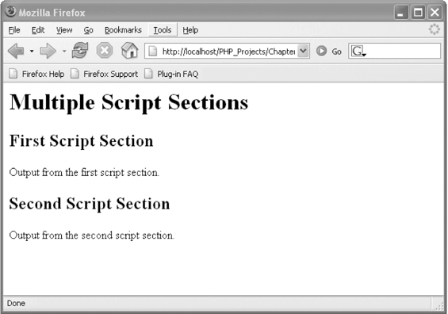

**Output of a document with two PHP script sections**

**6.8 Case Sensitivity in PHP**

* Programming language constructs in PHP are mostly case insensitive

<?php

echo “<p>Explore <strong>Africa</strong>, <br />”;

Echo “<strong>South America</strong>, <br />”;

ECHO “ and <strong>Australia</strong>!</p>”;

?>

**6.9 Creating Simple Contact Form**

<?php

if(isset($_POST['contact_name'])&&(isset($_POST['contact_address'])&&(isset($_POST['contact_text']))))

{

echo $contact_name=$_POST['contact_name'];

echo $contact_address=$_POST['contact_address'];

echo $contact_text=$_POST['contact_text'];

if(!empty($contact_name)||!empty($contact_address)||!empty($contact_text))

{

$to=’ananyabhatia129@gmail.com';

$subject='contact form submitted';

$body=$contact_name."\n".

$contact_text;

$headers='From:xyz@gmail.com'.$contact_address;

if(@mail($to,$subject,$body,$headers))

{

echo 'Thanks for contacting us.';

}

else

{

echo 'Sorry an error occured.please try again later.';

}

}

}

?>

<form action="prgrm8.php" method="POST">

Name:<br><input type="text" name="contact name"><br><br>

Email address:<br><input type="text" name="contact address"><br><br>

Message:<br><textarea name="contact_text" rows="6" cols="30"></textarea><br><br>

<input type="submit" value="send">

</form>

**O/P-**

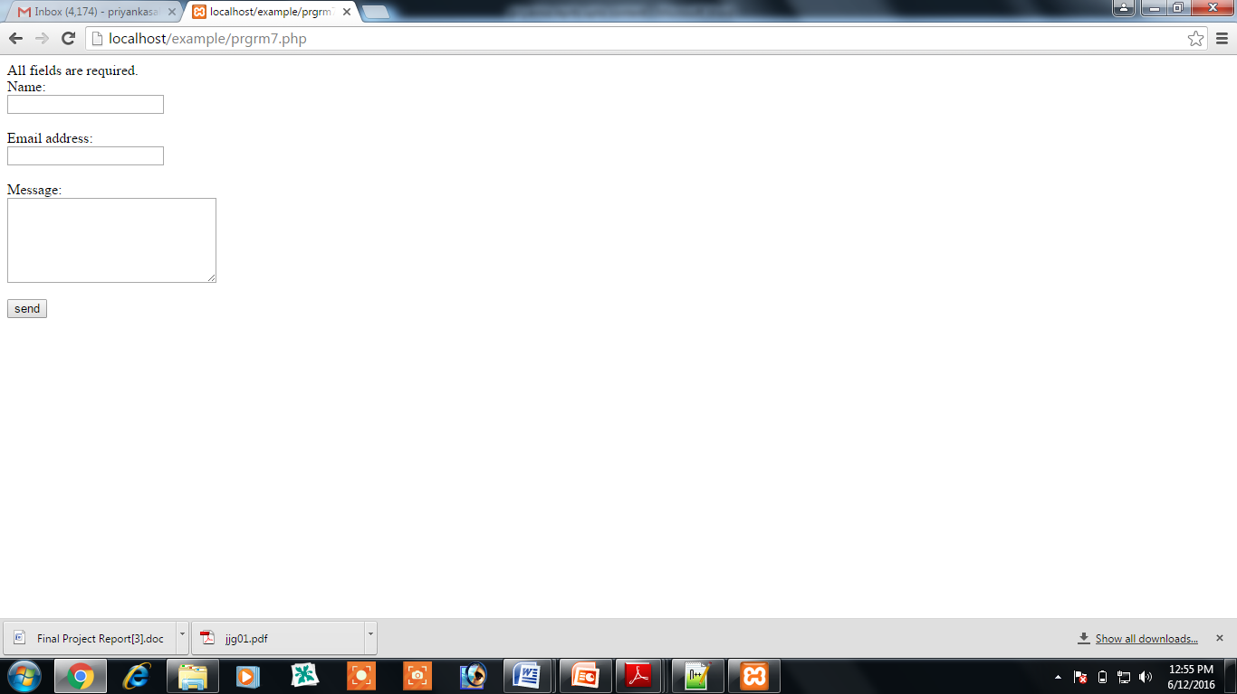

**6.10 Connecting to Server**

<?php

$conn_error = 'could not connect.';

$mysql_host="localhost";

$mysql_user = "root";

$mysql_pass = "";

$mysql_db='adatabase';

mysql_connect($mysql_host, $mysql_user, $mysql_pass) || die($conn_error);

mysql_select_db($mysql_db) || die($conn_error);

echo "Connected successfully";

?>

O/P-

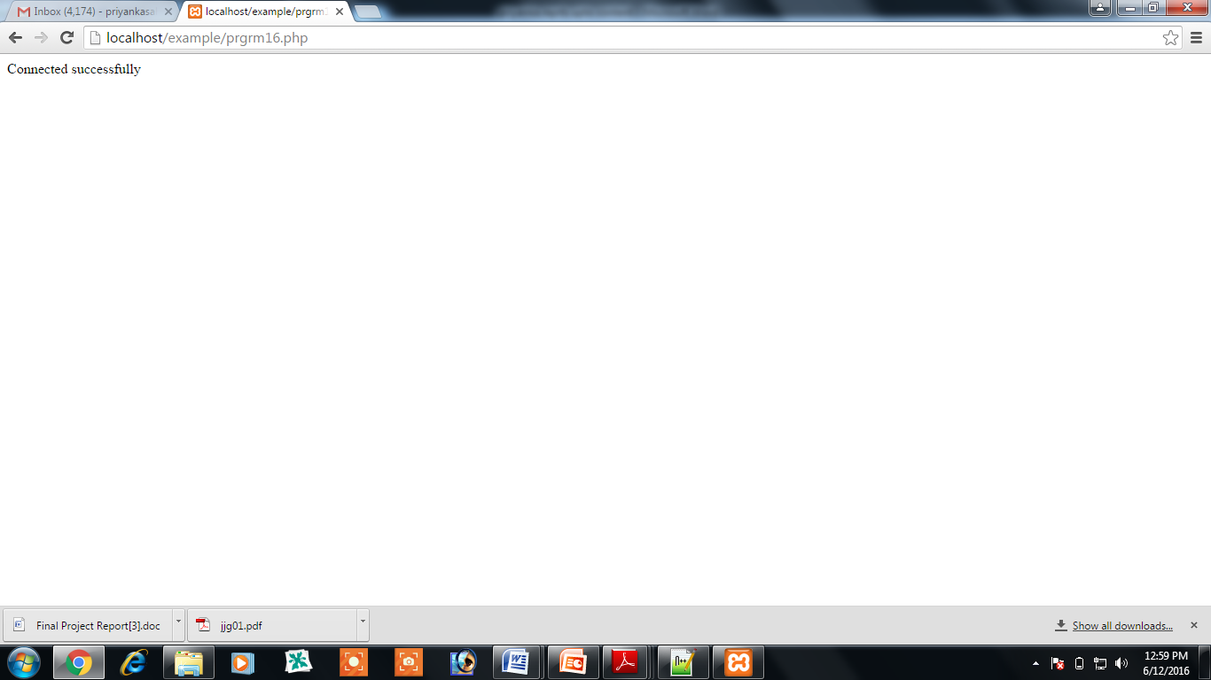

**7. Web Hosting**

**Hosting Services**

**7.1 Introduction to Hosting**

* The total costs of setting up your own in-house Web commerce site are expensive.
* Web hosting services allow businesses to start electronic commerce inexpensively.
* Web hosting services provide all the services that an ISP does.

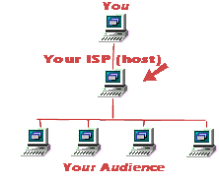

**7.2 Types of hosting services**

* Self-hosting
* Shared hosting
* Dedicated hosting
* Collocated hosting

**7.3 Implications of Self-hosting**

* The online business owns and maintains the server and all its software.
* It implies full control, instant hardware access, and complete flexibility.
* Business must have additional staff, Web expertise, expensive equipment, and a high-speed direct Internet connection.



**7.4 Implications of Shared Hosting**

* Your Web or commerce site resides on the same server as several other sites.
* It is inexpensive, requires very little of an online store’s time to maintain.
* It has a very high-speed connection to the Internet.
* It may lose direct control from online stores.
* Security concerns arise from unrelated online businesses sharing the same server.



**7.5 Implications of Dedicated Hosting**

* A Web host provides a server for your Web site alone.
* More Web and commerce software options, a good high-speed connection, more control to site’s design become available.
* Higher software costs and maintenance costs can be incurred.

**7.6 Implications of Collocated Hosting**

* The server is owned by the online store but is located at the Web host’s site.
* The Web host provides maintenance based on the level of service the online business requires.
* Maintenance costs are higher than self-hosting.
* “ValueWeb” is an example of a Web hosting service. It provides services of shared hosting, dedicated hosting, and collocation services.
  1. **Services Inside the Hosting**
* **File-transfer options:-**

You'll need to upload your site from your local machine to the server it lives on, and you may want people to be able to download files directly from your site. Look for a host that offers unlimited password-protected FTP uploads to get your site online

* **Mail options**

How much e-mail will you need for your domain? Estimate the number of mailboxes you'll want. You might pick one for each employee, for example, and add some for functions such as sales, info, complaints, and feedback provided by the hosting services

* **Site statistics**  
  You may not think much about hit rates and browser versions and types now, but once you get the site off the ground, you might want site statistic tools so that you can evaluate traffic and plan future site development.

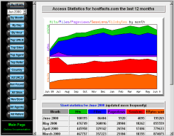

* 1. **Factors to evaluate a hosting service**
* Functionality
* Reliability
* Bandwidth and server scalability
* Security
* Backup and disaster recovery
* Cost
  1. **How to find Hosts**
* Make a shortlist of your needs
* Comb directories of Web hosting companies
  + CNET's [list of basic hosts](http://www.cnet.com/exredirect/template/1,10048,,00.html?tag=ex.is.3799-8-9483364-4.txt.ws_hostplans&destURL=http%3A%2F%2Fwebservices%2Ecnet%2Ecom%2Fcgi%2Fscompare%2Easp%3Fstable%3DHosting%5FPlans)
  + the [Web Host Directory](http://www.cnet.com/exredirect/template/1,10048,,00.html?tag=ex.is.3799-8-9483364-4.txt.ex_webhostdir&destURL=http%3A%2F%2Fwww%2Ewebhostdir%2Ecom%2F)
  + [TopHosts](http://www.cnet.com/exredirect/template/1,10048,,00.html?tag=ex.is.3799-8-9483364-4.txt.ex_tophosts&destURL=http%3A%2F%2Fwww%2Etophosts%2Ecom)
  + [WebHosters.com](http://www.cnet.com/exredirect/template/1,10048,,00.html?tag=ex.is.3799-8-9483364-4.txt.ex_webhosters&destURL=http%3A%2F%2Fwww%2Ewebhosters%2Ecom%2F)
  + and the [Web Hosts List](http://www.cnet.com/exredirect/template/1,10048,,00.html?tag=ex.is.3799-8-9483364-4.txt.ex_thelist&destURL=http%3A%2F%2Fwebhosts%2Ethelist%2Ecom%2F).
* Shorten the list by first picking the type of hosting that suits you best (basic, shared, e-commerce, dedicated, and so on).
* Next, look for plans that satisfy both your budget and basic requirements.

1. **Design of a Web-Based Project-Based Learning Model**

**8.1 Web-Based Project-Based Learning**

One of the most promising ways the Internet is being utilized in school is to have students participate in global collaborative Internet projects. In this section, wepropose a learning model called the Web-Based Project-Based Learning (hereinafter called ‘Web Project Learning’) for the Web environment. The Web Project Learning is defined as problem-oriented learning within the framework of a small group, a whole class, or an individual project and using web support for the project activities.It also provides real-life contexts for successful collaborative learning .In teaching, the Web fits very well with the Project-Based Learning Model. The Web can be an organizer, a research tool, a ready source of data, a means for people to communicate with each other, and a repository for artifacts. Because the Web is a part of the real world, and artifacts on the Web can readily be placed in the world beyond school, projects have a scope for authenticity not usually found in the school environment..The Web Project Learning can motivate both students and teachers as it provides an appealing way for students to gain Internet skills while being engaged in regularclassroom activities. Through the projects, students are encouraged to develop a range

of skills relating to reading, writing and researching as well as developing their

abilities in selecting, presenting and communicating information. When students work

on their project, they strengthen research and organization skills while being

responsible and self-motivated all skills they will need in the information age.

Students feel a sense of engagement because they work with topics that they have

chosen for themselves.

**3.2. Web-Based Project-Based Learning Model**

**Getting ready**

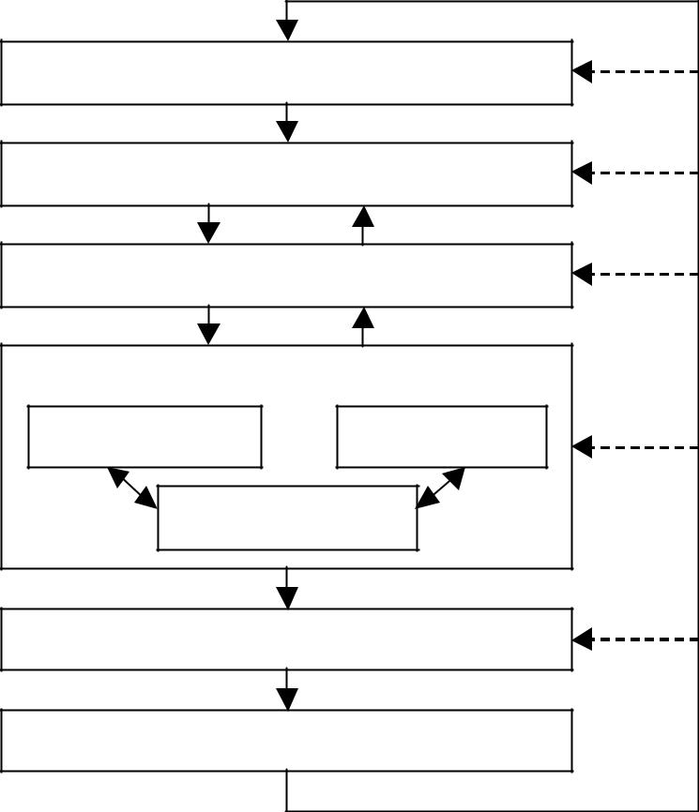

Deciding topic

Planning activities

Investigating & Representation

Investigation Discussion

Representatio

Finishing

Evaluating

The Web Project Learning Model is divided into the following six phases instead

of only three phases , which are Getting Started, Field Work and Culminating and Debriefing Events

**1. Getting ready**. First of all, a teacher designs a project outline. The outline’s

purpose is to provide the information necessary for students to envision their own

project within the scope of the outline, and provide resources to help them carry it out.

It must provide goals of the whole project for students, and sufficient guidance for

students to choose appropriate questions, activities, and products. The outline will be

mainly read and used by students. A teacher analyzes and integrates curriculum, lists

questions, researches Web sites or resources that can be helpful for students to

investigate during the course of the project, and post on the Web.

**2. Deciding topic**. Students read the Web Project outline and search for resources.

References to resources consist of URLs to relevant Web materials so that students

can be directed immediately to high quality materials that match the project needs.

Students recall their own past experiences related to the project, make topic map and

exchange their ideas. During preliminary learning, the students decide subtopics of

the project for themselves.

**3. Planning activities**. Students work on individual student projects, in-class

collaborative projects, or class-to-class projects. They determine the activities and

events that will take place at each stage of their subtopics, plan appropriate timelines

for all their subtopics, and post on the Web. If they work on a collaborative learning

project, each team member must have specific roles and responsibilities. Teachers

communicate contents of project planning to parents so that they can help and support

their children work on the projects.

**4. Investigating and Representation**. Investigation includes activities such as

interviewing experts through e-mail, investigating Web sites, and sharing exchange

new experience and knowledge and doing a survey through the Web. In addition, it

includes observations, experiments and field trips. Discussion includes both

synchronous and asynchronous communication through the chatting or bulletin board

system. Representation includes drawing, painting, writing, math diagrams, maps, etc.

to represent new learning. Regularly, parents report the children’s condition to

teachers.

**5. Finishing**. Students produce reports, presentations, Web pages, images, pictures,

construction, etc. as a result of the activity, share their end products, and celebrate

them on the Web. Teachers have students write down their reflections on the project

and things to remember for next time.